Hydrogen Station Capacity Evaluation

Sam Sprik, Dani Murphy, Taichi Kuroki, Danny Terlip, Josh Eichman, Michael Penev, Jennifer Kurtz

Acknowledgments

Enter text

List of Acronyms

ELP electrolyzer/liquid/pipeline

HP High pressure

LP Low pressure

MP Medium pressure

NREL National Renewable Energy Laboratory

SOC State of charge

TT Tube trailer

Executive Summary

The Hydrogen Station Capacity Evaluation tool (HySCapE) is a tool developed by the National Renewable Energy Lab (NREL) to estimate hydrogen station capacity. The tool allows for simulation of multiple station configurations at a time step of one second. Users define the characteristics of major station components. This document outlines the applications for this tool, the underlying operating algorithm, available user inputs, simulation outputs, assumptions made by NREL and sample hydrogen station calculations.

Table of Contents

1 Introduction 1

2 HySCapE Inputs, Assumptions, and Outputs 1

3 Operational Algorithms 5

4 Sample Station Capacity Estimates 11

4.1 Sample Station – Gas Delivered, 200 kg storage 11

4.2 Sample Station – Gas Delivered, 600 kg storage 12

4.3 Sample Station – Gas Delivered, 900 kg storage 13

4.4 Sample Station – Gas Delivered, 900 kg storage, 2 fueling positions 13

4.5 Sample Station – Liquid Delivered 15

4.6 Sample Station – Production 16

5 Conclusions 16

References 17

List of Figures

Figure 1. Sample station configuration 1

Figure 2. Station user input data (part a) 2

Figure 3. User defined station data (part b) 3

Figure 4. HySCapE compiled executable user interface 3

Figure 5. Actual hydrogen fueling profile compared with the “Friday” profile used for the capacity calculations 4

Figure 6. HySCapE programmatic flow diagram 5

Figure 7. Dispensing Algorithm flow diagram 6

Figure 8. Dispenser Algorithm programmatic flow diagram 7

Figure 9. Keep performing active fills programmatic flow diagram 7

Figure 10. Hydrogen production programmatic flow diagram 8

Figure 11. Hydrogen compression programmatic flow diagram 9

Figure 12. Electrolyzer/liquid/pipeline compression algorithm programmatic flow diagram 9

Figure 13. Hydrogen delivery algorithm programmatic flow diagram 10

Figure 14. Ending vehicle SOC comparison for experimental vs model results 11

Figure 15. Gas delivered, ~200 kg storage 12

Figure 16. Gas delivered, ~600 kg storage 12

Figure 17. Gas delivered, ~900 kg storage 13

Figure 18. Gas delivered, ~900 kg storage, 2 fueling positions 14

Figure 19. Comparison of ~900 kg station masses with 1 (left side) and 2 (right side) fueling positions 14

Figure 20. Comparison of ~900 kg station pressures with 1 (left side) and 2 (right side) fueling positions 15

Figure 21. Liquid delivered, ~1,500 kg storage 15

Figure 22. Production, ~200 kg storage 16

List of Tables

Table 1. Sample Station Comparison 11

1. Introduction

The Hydrogen Station Capacity Evaluation (HySCapE) model is designed to estimate hydrogen station capacity, based on user inputs for the hydrogen station capacity and pre-defined fueling demand profile. HySCapE is a mass balance model with simple, transparent methods for capacity estimation that can be consistently applied for different station configurations. This model is not a design tool or customized for individual station details like control strategy.

HySCapE reads the external user inputs and balances mass every second based on the predefined fueling demand scenario. The capacity calculation utilizes CSA HGV 4.9 [1] as the basis to determine one fill. The model has algorithms for dispensing, compression, delivery, and production, see Figure 1 for an example station configuration. HySCapE outputs the number of kilograms (kg) dispensed in total and for full fills. A full fill is assumed to be greater than or equal to 95% state-of-charge (SOC). The output also includes more details on fill count, amount, duration, ending SOC, and station storage pressures and masses for the user to see how the algorithms were applied.



Figure 1. Sample station configuration

HySCapE is currently a compiled Matlab executable. The details in this report are all based on the compiled executable user interface. An online user interface is in development, expected the fall of 2018, with no planned changes to the model algorithms.

1. HySCapE Inputs, Assumptions, and Outputs

HySCapE accepts three main groups of user inputs

* Hydrogen production profile – details the time and rate of hydrogen production
* Hydrogen delivery profile – details the time and amount of hydrogen that arrives in delivery trucks
* Station component characteristics – details the specifications of major station components

The user uses a spreadsheet for station details as shown in Figure 2 and Figure 3. The first 6 data rows are to identify what cells need to be entered based on major station components like gas or liquid delivery, on-site production, and storage pressures. The inputs shown in Figure 2 and Figure 3 are for a station that matches the sample configuration shown in Figure 1.

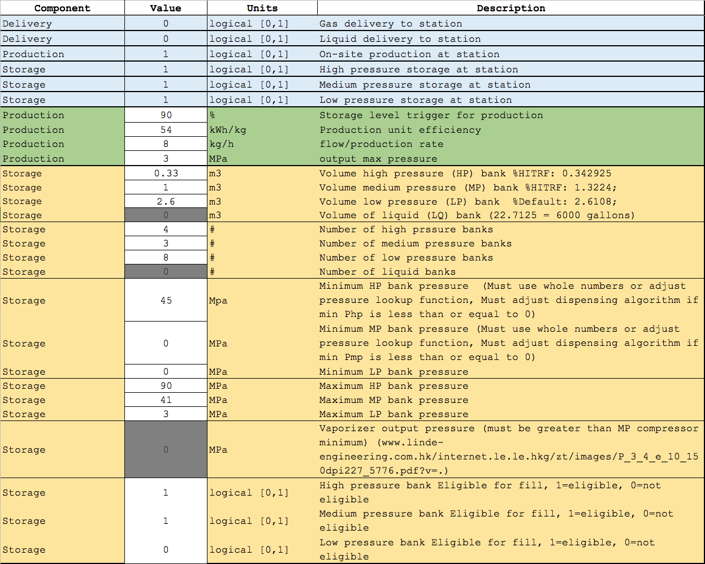

Figure 2. Station user input data (part a)

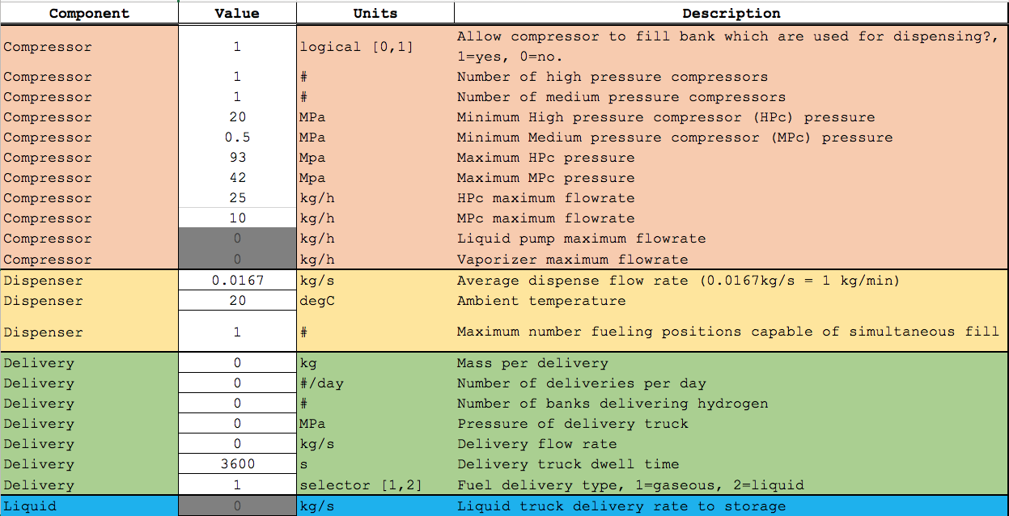

Figure 3. User defined station data (part b)

The dispenser algorithm assumes a constant ambient temperature and an average flow rate. These values were able to be modified by the user in the spreadsheet, but they will not be editable inputs in the online user interface. A user may input station characteristics through file import using the main user interface (Figure 4). The executable, input file(s), and output folder must be located locally.

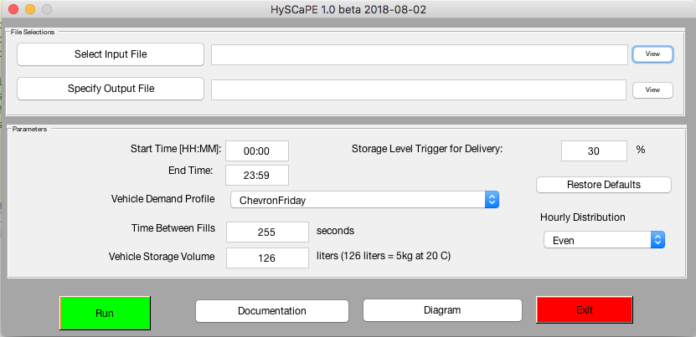

Figure 4. HySCapE compiled executable user interface

A fill is predefined in amount and profile. The vehicle storage volume is 126 liters (or 5 kg at 20oC), with a starting pressure of 10 MPa (approximately 1 kg). The ending fill pressure is 70 MPa. The fill demand profile is over 24 hours and follows the “Friday” profile from the Figure 2-16, page 2-39) the “Hydrogen Delivery Infrastructure Options Analysis”[2]. The number of fills varies for each hour per this profile and keeps the starting conditions consistent, except for partial fills based on the demand profile. A partial fill increases the starting pressure linearly. For example, the profile has 1.2 fills so the model will try one full fill (4 kg) and then another fill of only approximately 0.9 kg.

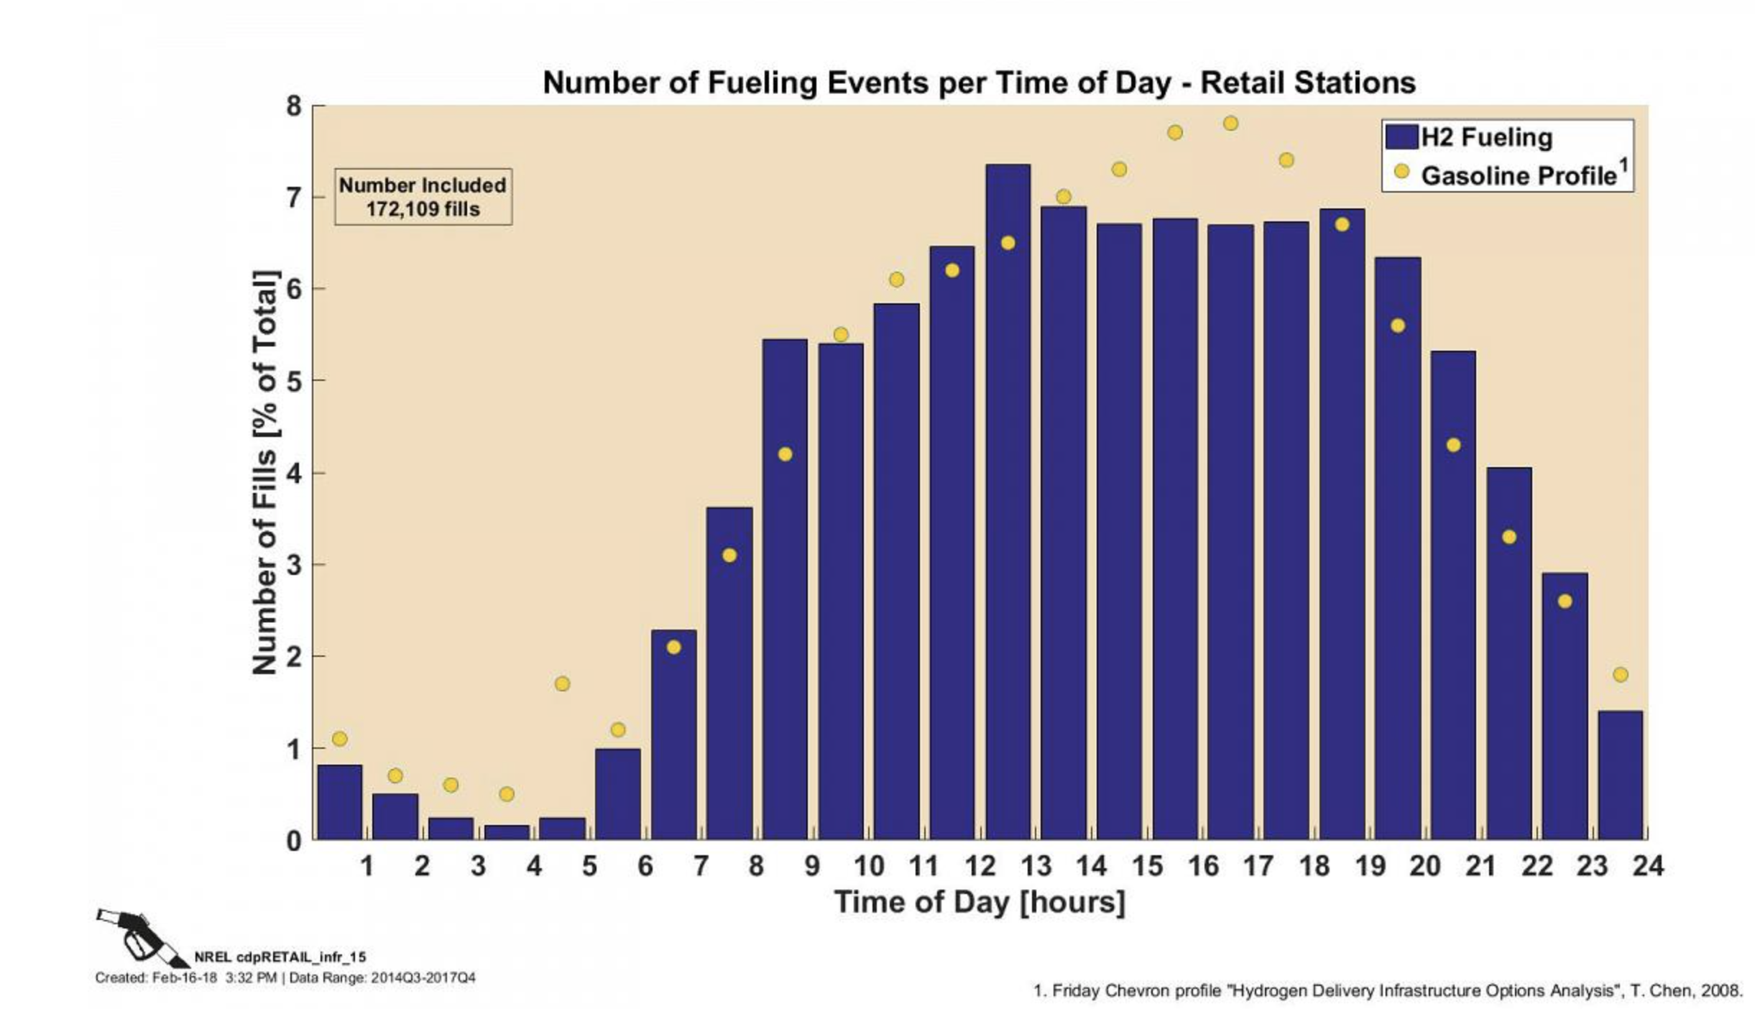

Figure 5. Actual hydrogen fueling profile compared with the “Friday” profile used for the capacity calculations

The model makes a number of assumptions to replicate a possible real-world fueling scenario and be consistent for capacity calculations even though actual fueling may vary from these assumptions.

* The model assumes a constant ambient temperature for all components, including the vehicle, at 20oC
* The demand profile and fill conditions are predetermined
* The dispenser operates with a constant mass flow rate (average of 1 kg/min per SAE J2601), without leak checks during dispensing
* The maximum time between fills is 4 minutes, 15 seconds and the minimum is 1 minute
* The station begins with 100% SOC
* All pressure banks are eligible for cascade fueling
* Compression is scaled linearly based on suction pressure
* Delivery is allowed, based on user input for amount delivered and a station SOC trigger for when the delivery happens
* All equipment works as specified without failures
* The model does not consider dynamics shorter than one second
* All equipment begins operation at the specified time (no priming or warm up times are included)
* The station has no leaks
* No hydrogen is vented during normal operation (e.g., compressor or dispenser unloading)
* On-site production and pipeline have a flow-rate input
* Multiple fueling positions multiples the demand profile, offsets the fill start time by 1 second
* Partial fills are allowed if the station is not able to complete a full fill

The model completed external user beta testing prior to HySCapE version 1.0 release.

1. Operational Algorithms

This section describes the logic in the HySCapE model to calculate station capacity. The high-level program algorithm is given first. Following this, each program section is detailed with a flow chart. These detailed flow charts are represented by diamonds, rectangles and arrows. Diamonds represent decision blocks, rectangles represent action blocks, and arrows represent normal program flow (Figure 6).

Decision Block

Action Block

Program Flow

Figure 6. Flow chart legend

From the highest level, the model operates in a sequential method that is represented by the flow chart in Figure 6. The program initializes variables based on user input which may be gathered from a GUI or read from external files – typically comma separated variable. The program then enters the main loop. The first step in the loop is to resolve the station state (i.e. storage and vehicle pressures) either based on the initialization or previous state. This is proceeded by the execution of dispensing, compression and production/delivery algorithms are executed. Finally, the program updates storage and vehicle mass values based on compression, production, dispensing or delivery. The main loop is terminated when the vehicle fill profile has been completely executed. At this point, the program computes a summary of the station performance and outputs results to the user. The time resolution for the model is set to one second as the default, meaning that the main loop proceeds one second at a time for the desired duration of the scenario (e.g., 24 hours).

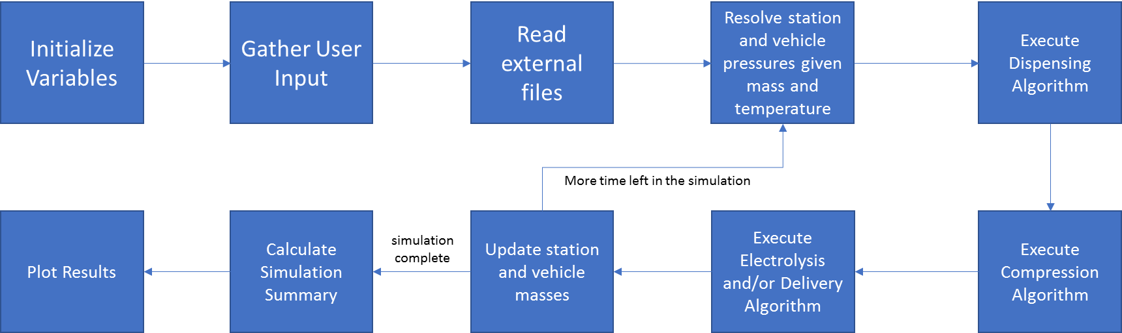

Figure 7. HySCapE programmatic flow diagram

The first action executed by the program is the Dispensing Algorithm, which is composed of the filling schedule and dispenser operation (see Figure 7). The user specified vehicle fill schedule determines whether a dispenser is activated. If a vehicle is at the station requesting a fill and a dispenser and fuel are available, then the program will execute the Dispenser Algorithm. If not, the program will wait, a user defined time. If this time elapses without a dispenser or fuel becoming available, then the vehicle will leave the station without a fill. The user can specify how many fueling positions are available.

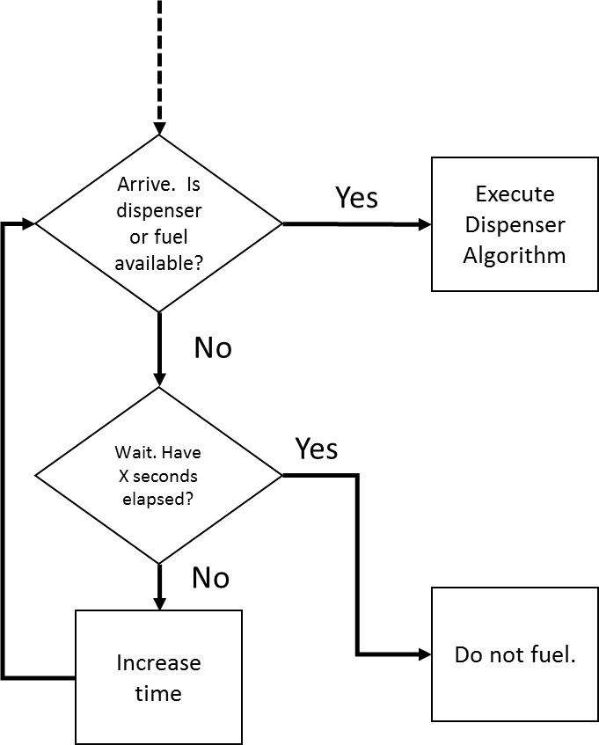

Figure 8. Dispensing Algorithm flow diagram

The Dispenser Algorithm specifically governs which dispenser and which storage volume is used to fill a vehicle. LP, MP, and HP are all eligible for cascade fueling. The logic is shown in Figure 8. The algorithm has various paths that handle conditions that arise during a fill event such as starting a new fill or performing a bank change. If neither of these tasks are applicable, the “Keep performing active fills” block is executed.

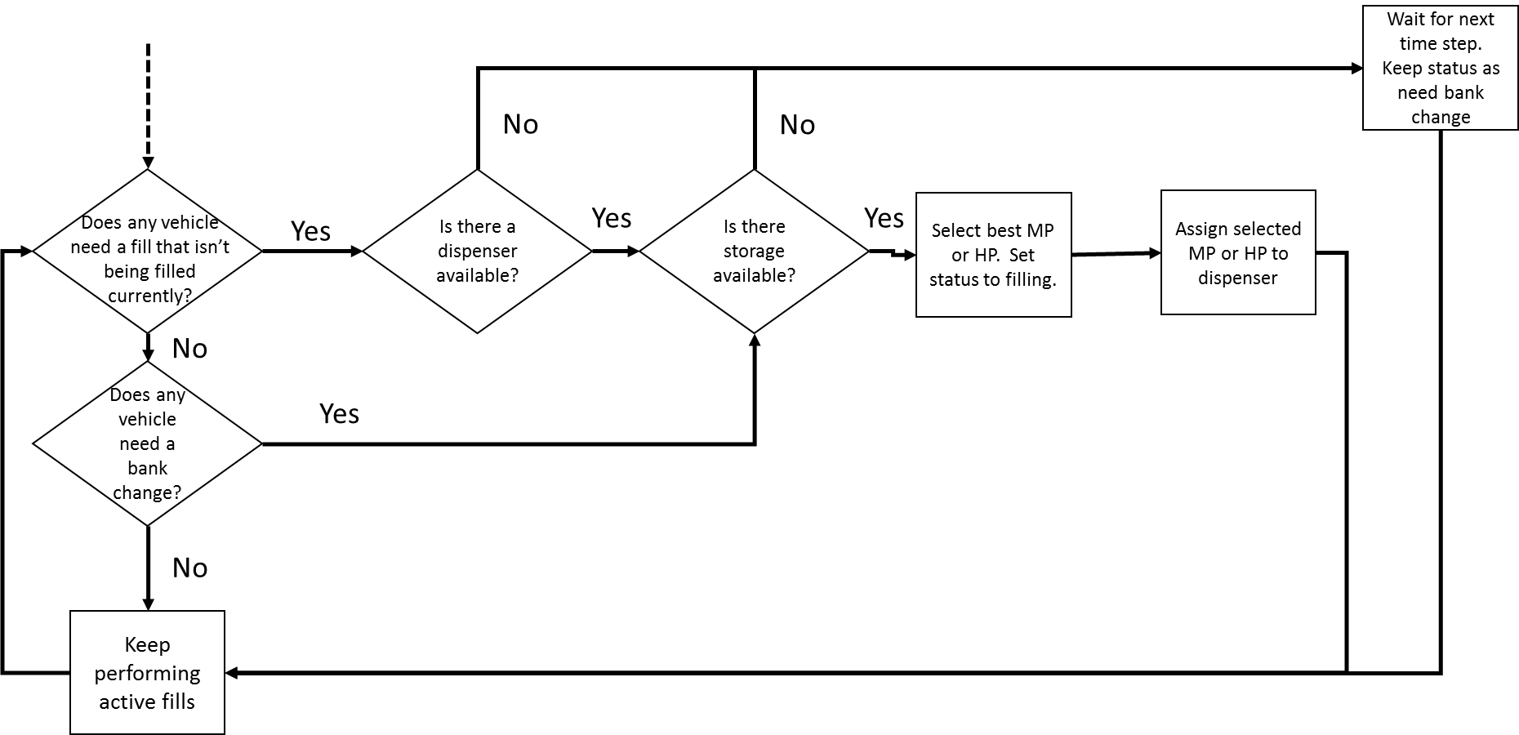

Figure 9. Dispenser Algorithm programmatic flow diagram

The “Keep performing active fills” block is expanded in Figure 9. This subroutine is responsible for adding mass to the vehicle and subtracting mass from the station. If either of these processes result in a full vehicle or empty station tank, the subroutine informs the Dispenser Algorithm above. The program compares the vehicle SOC to the SAE J2601 specified maximum density (40.22 g/L) to determine when the vehicle is full. Pressure ramp rates are not currently used for the fill profile. Instead, the program has a constant mass flow rate and monitors a pressure differential between the station storage used and the vehicle storage. If the pressure differential falls below the constant specified (e.g. 10 MPa) then the routine requests a bank change. If no other banks remain, the constant specified is reduced (e.g. 2 MPa) to allow for maximum hydrogen delivery.

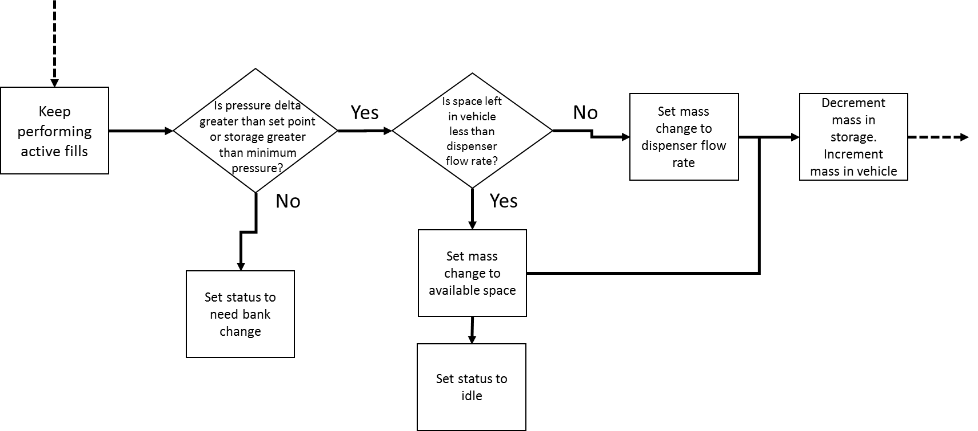

Figure 10. Keep performing active fills programmatic flow diagram

The hydrogen production algorithm is simple. A user defines when the production mechanism (e.g. electrolyzer or SMR unit) operates and at what flow rate. The program logs the operation time, energy consumption and hydrogen production. If the production unit produces hydrogen that the station cannot accept, due to hydrogen compression limitations or the hydrogen storage tanks are full, the hydrogen will be vented.

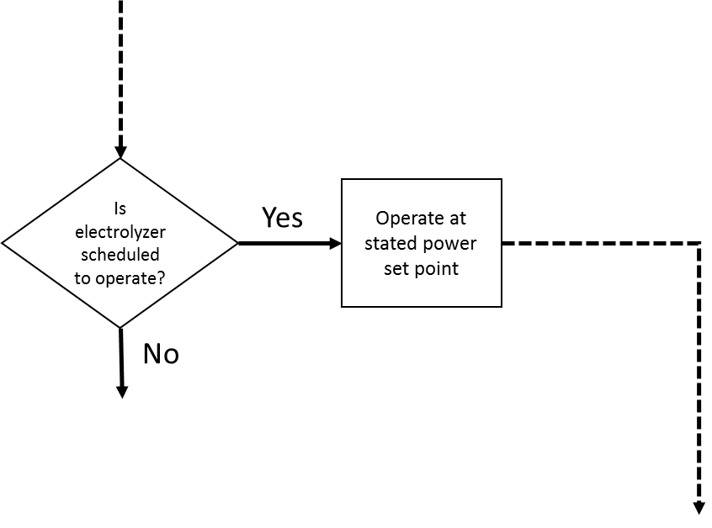

Figure 11. Hydrogen production programmatic flow diagram

The hydrogen compression algorithm is shown in Figure 11. This algorithm maintains the storage banks in the station at user defined pressure levels. It decides which tanks to draw from and compress to and manages the flow rate of the compressor. The user can define any number of high pressure (HP), medium pressure (MP), or low pressure (LP) banks as well as any number of MP or HP compressors. The user can also define a flowrate for the MP compressors and one for the HP compressors. The algorithm also allows for compression direct from LP to HP, as well as compression into a bank that is also eligible for fueling.

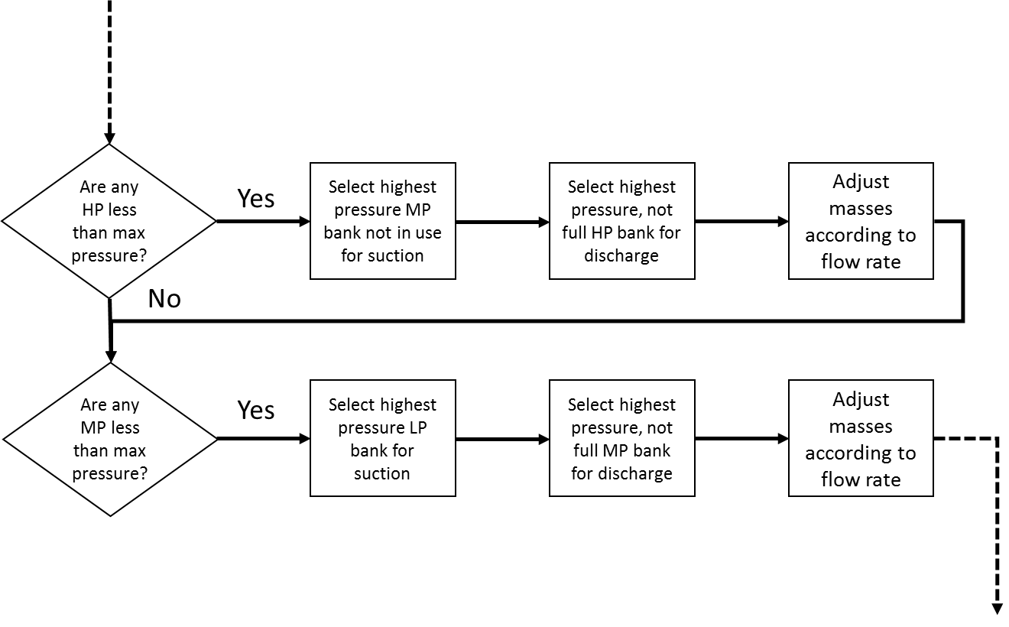

Figure 12. Hydrogen compression programmatic flow diagram

The electrolyzer/liquid/pipeline (ELP) compression algorithm handles more complex station operation, such as multiple production units, pipeline or liquid supply or multiple compressors. The flow diagram is shown in Figure 12.

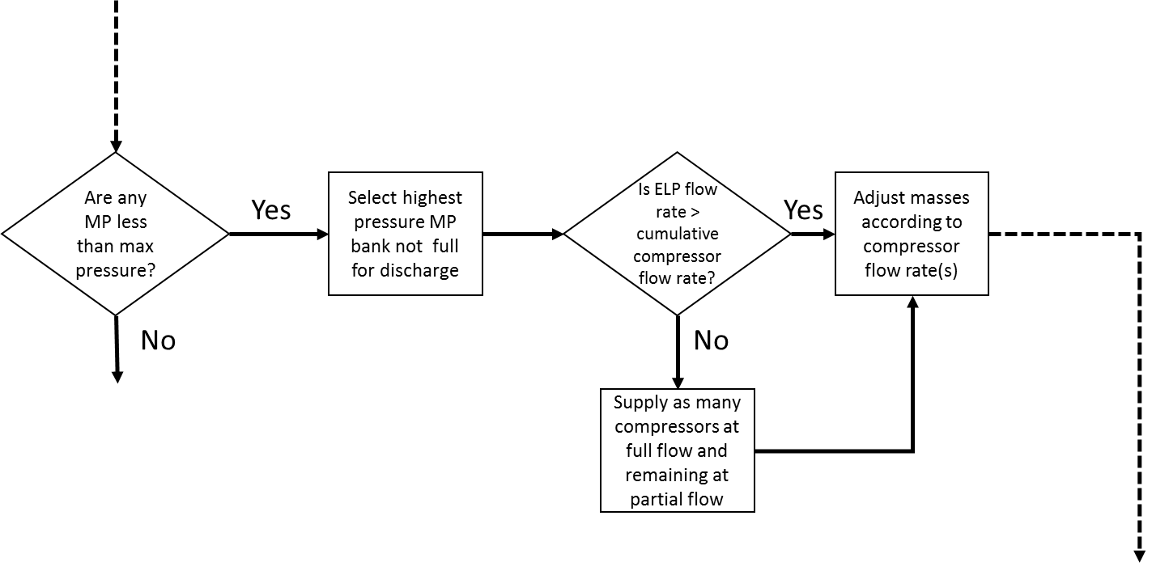

Figure 13. Electrolyzer/liquid/pipeline compression algorithm programmatic flow diagram

The hydrogen Delivery Algorithm is responsible for distributing hydrogen from a tube trailer to station ground storage. The algorithm has two paths depending on the phase of the delivery. For gaseous hydrogen, the gas is distributed all at once, while the liquid moves at a user defined flow rate. The trailer fills with a cascade algorithm that starts with the station storage bank with a pressure closest, but not exceeding the highest tube trailer bank. As those pressures equalize, the next highest station bank is filled and so on.

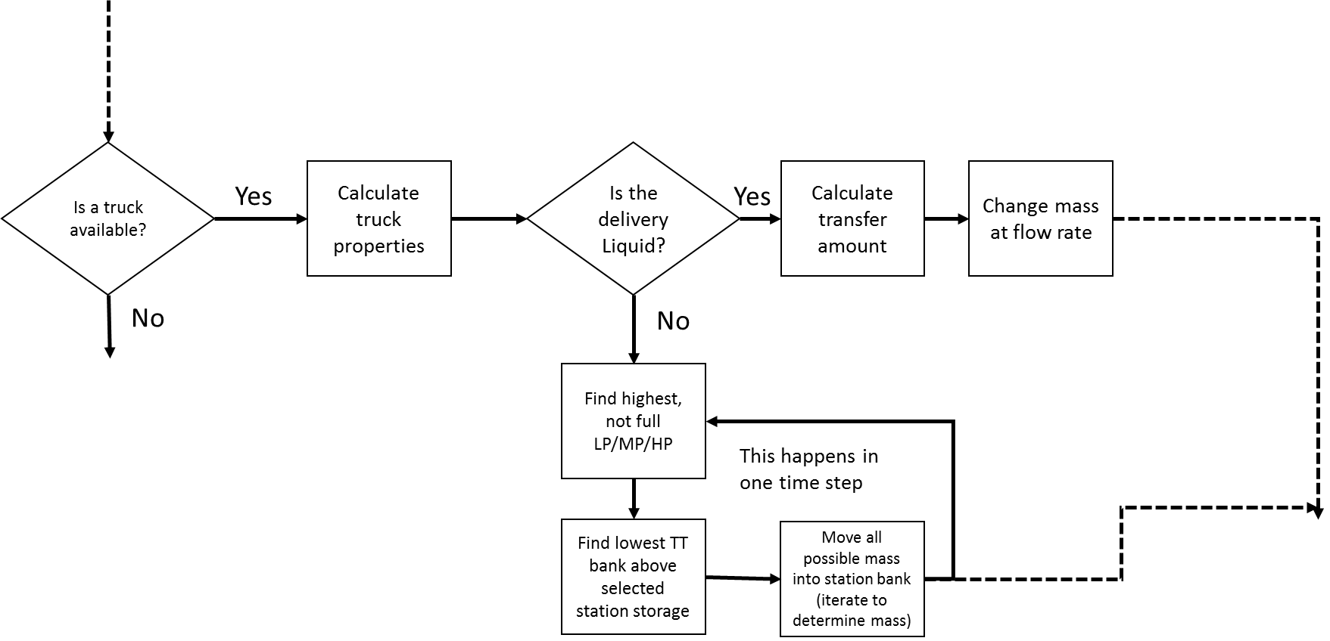

Figure 14. Hydrogen delivery algorithm programmatic flow diagram

The operational algorithms were validated using data collected at the Hydrogen Infrastructure Testing and Research Facility[1] (HITRF) on NREL’s campus. Station inputs were set to match NREL’s research station while vehicle fill profiles, starting SOC, and initial storage tank pressures were taken from experimental testing which took place on May 21, 2018. A total of 30 vehicles banks (comprised of three tanks with a total bank volume of 108 L) were filled in less than 9 hours. The HySCapE capacity calculation trends appropriately for the vehicle fill segments, with back-to-back vehicle fills receiving successively lower SOC, the model over-predicts SOC compared to experimental results (Figure 14). This error can largely be contributed to the constant temperature assumption in the model. It is well known that vehicle tank temperatures increase due to heat of compression during a fill. The current model does not predict temperature increase; therefore, more mass is transferred to the vehicle before the full tank pressure setpoint is achieved. Although the final SOC is overpredicted in the model, the predicted total mass dispensed falls within reasonable experimental error. The model predicted 107.5 kg dispensed, while experimental values ranged between 97.5 and 110.3 kg dispensed for vehicle and storage tank mass change respectively. Experimental error can be attributed to many factors including measurement error and thermocouple location.

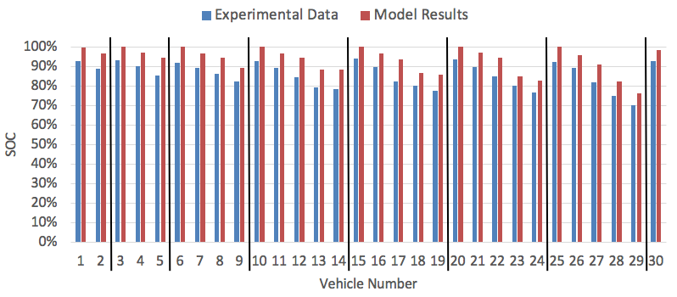

Figure 15. Ending vehicle SOC comparison for experimental vs model results

1. Sample Station Capacity Estimates

The following are results of 6 sample stations, which represent common station configurations. There are many possible variations that are not included here.

Table 1. Sample Station Comparison

| Description | Station Storage [kg] | Total H2 Dispensed [kg] | Full Fill H2 Dispensed [kg] | H2 Delivered [kg] | H2 Produced [kg] |
| --- | --- | --- | --- | --- | --- |
| Gas Delivered, ~200 kg | 202 | 131 | 55 | 0 | 0 |
| Gas Delivered, ~600 kg | 688 | 372 | 296 | 0 | 0 |
| Gas Delivered, ~900 kg | 908 | 476 | 476 | 0 | 0 |
| Gas Delivered, ~900 kgb | 908 | 698 | 440 | 171 | 0 |
| Liquid, ~1,500 kg | 1477 | 476 | 476 | 0 | 0 |
| Production, ~200 kg | 174 | 196 | 87 | 0 | 144 |

1. All sample stations had 180 second between fueling.
2. All sample stations had 1 fueling position (# fills over 24 hours), except the second ~900 kg gas delivered sample station
   1. Sample Station – Gas Delivered, 200 kg storage

This sample station has LP, MP, and HP storage banks with a MP and HP compressor. See Figure 15 for the calculated fill data, with the predetermined fueling demand.

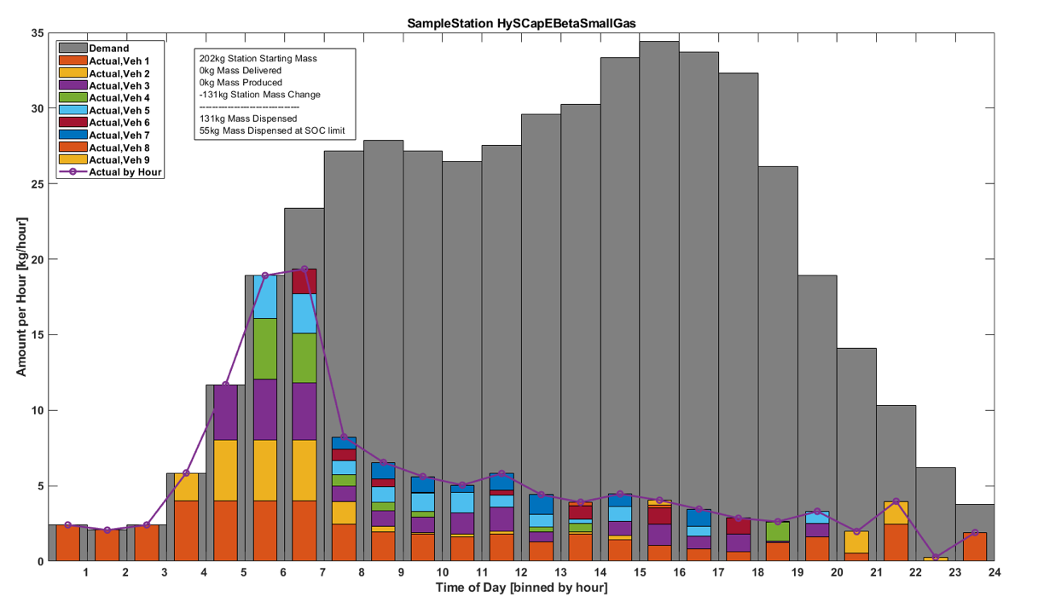

Figure 16. Gas delivered, ~200 kg storage

* 1. Sample Station – Gas Delivered, 600 kg storage

This sample station has LP, MP, and HP storage banks. See Figure 16 for the calculated fill data, with the predetermined fueling demand.

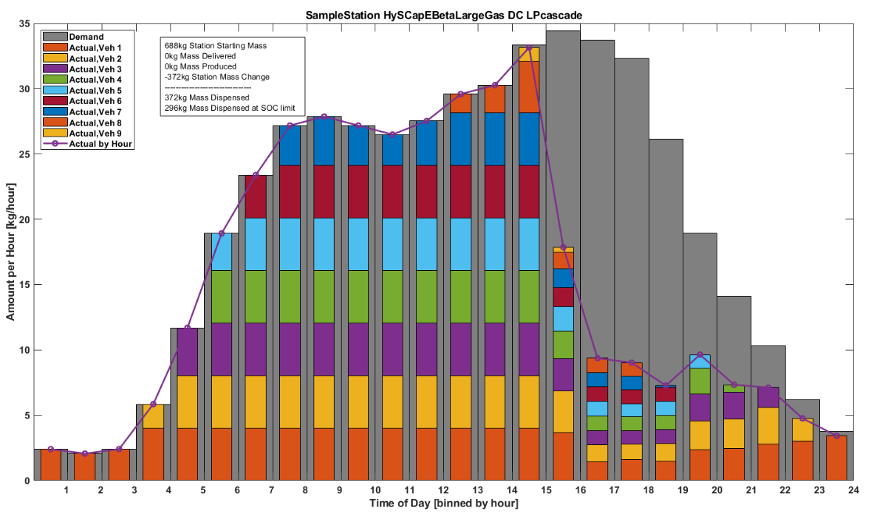

Figure 17. Gas delivered, ~600 kg storage

* 1. Sample Station – Gas Delivered, 900 kg storage

This sample station has LP and HP storage banks with the LP eligible for cascade filling. This station configuration also allows for filling and compression in the same bank at the same time. See Figure 17 for the calculated fill data, with the predetermined fueling demand.

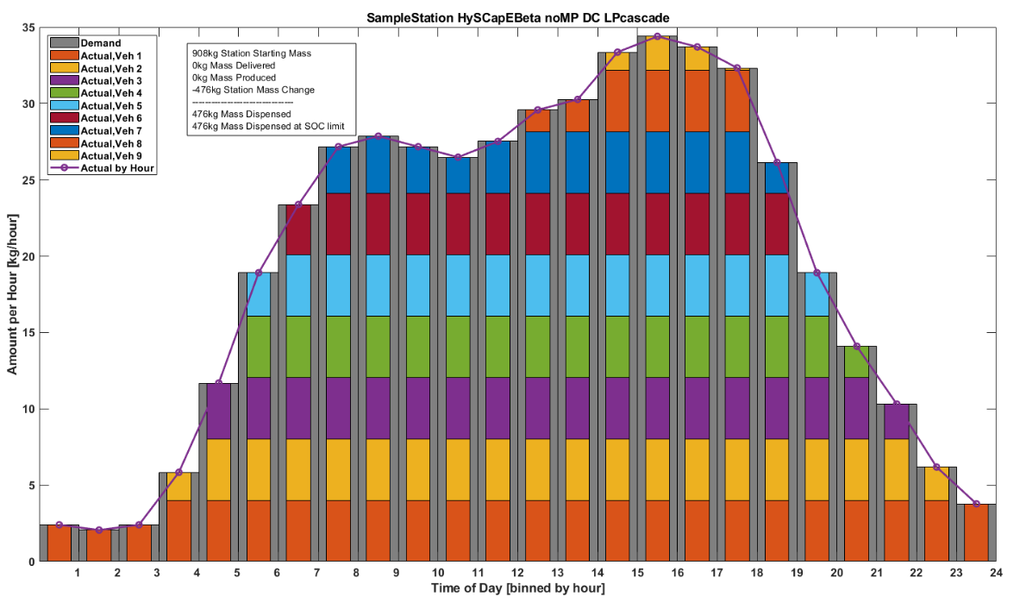

Figure 18. Gas delivered, ~900 kg storage

* 1. Sample Station – Gas Delivered, 900 kg storage, 2 fueling positions

This sample station is the same station as 4.3, except with 2 fueling positions. The full fill dispensed is calculated as less than the same station with 1 fueling positions because more fills have happening early in the 24-hour period. See Figure 18 for the calculated fill data, with the predetermined fueling demand.

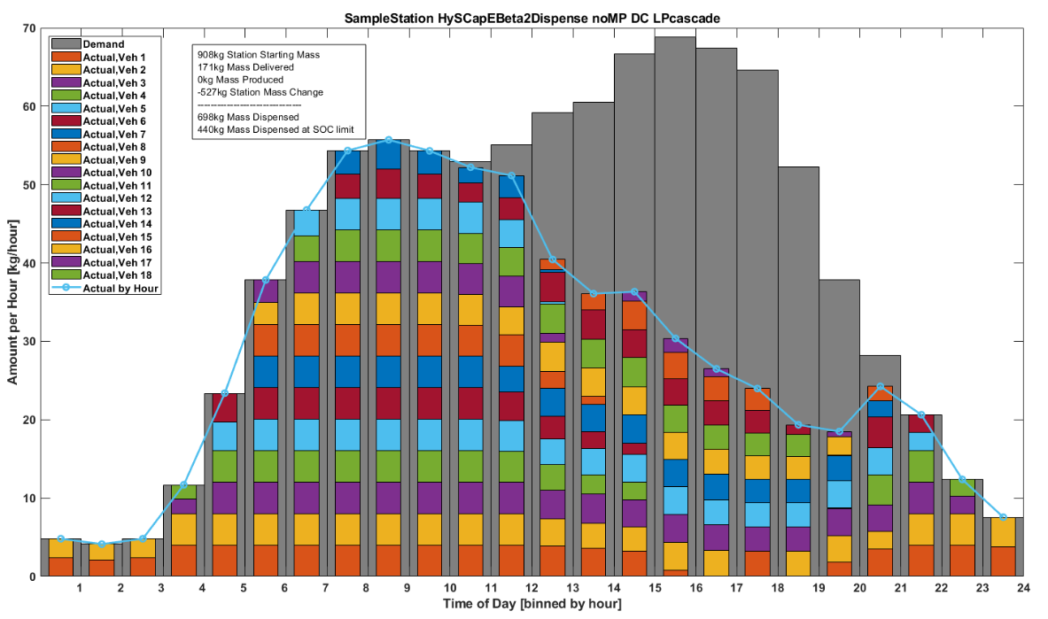

Figure 19. Gas delivered, ~900 kg storage, 2 fueling positions

Figure 19 has a comparison of the station masses (HP, LP, and vehicle fills) for 1 and 2 fueling positions. In the scenario with 1 fueling position, the LP banks reach 40 kg near the end of the 24-hour period. In the scenario with 2 fueling positions, the LP banks reach 40 kg around mid-day. The station SOC delivery trigger, set to 30% for this example, could be modified for earlier to potentially increase the number of full fills completed. The starting mass of the vehicle is shown in the green circle and the ending mass of the vehicle is the red asterisk. The scenario with 1 fueling position completes full fills for all of the fills.

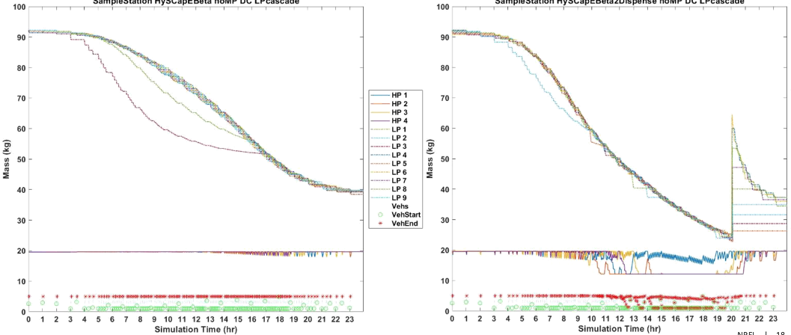

Figure 20. Comparison of ~900 kg station masses with 1 (left side) and 2 (right side) fueling positions

Figure 20 has a comparison of the station pressures (HP, LP, and vehicle fills) for 1 and 2 fueling positions. In the scenario with 1 fueling position, the LP banks go below 20 MPa near the end of the 24-hour period. In the scenario with 2 fueling positions, the LP banks reach 10 MPa around 8 pm. The starting pressure of the vehicle is shown in the green circle and the ending pressure of the vehicle is the red asterisk. The scenario with 1 fueling position completes full fills for all of the fills.

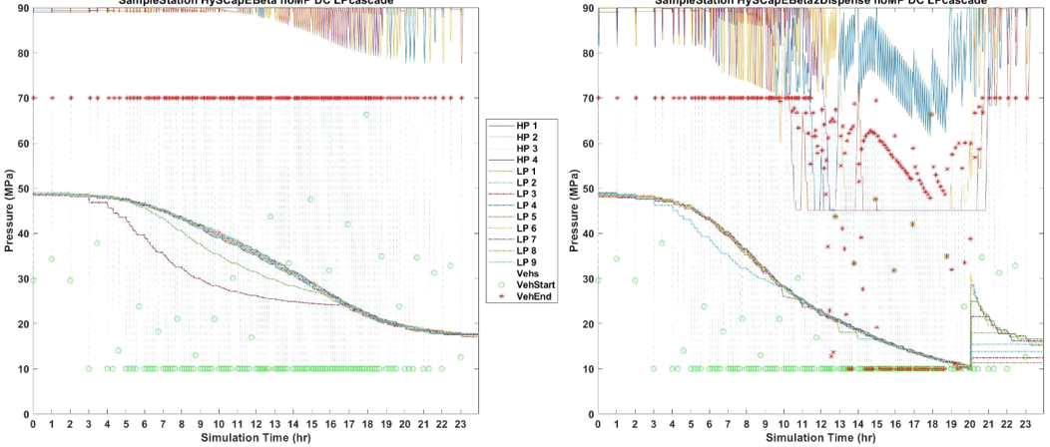

Figure 21. Comparison of ~900 kg station pressures with 1 (left side) and 2 (right side) fueling positions

* 1. Sample Station – Liquid Delivered

This sample station has delivered liquid with a low-pressure vaporizer and HP compressor. See Figure 21 for the calculated fill data, with the predetermined fueling demand.

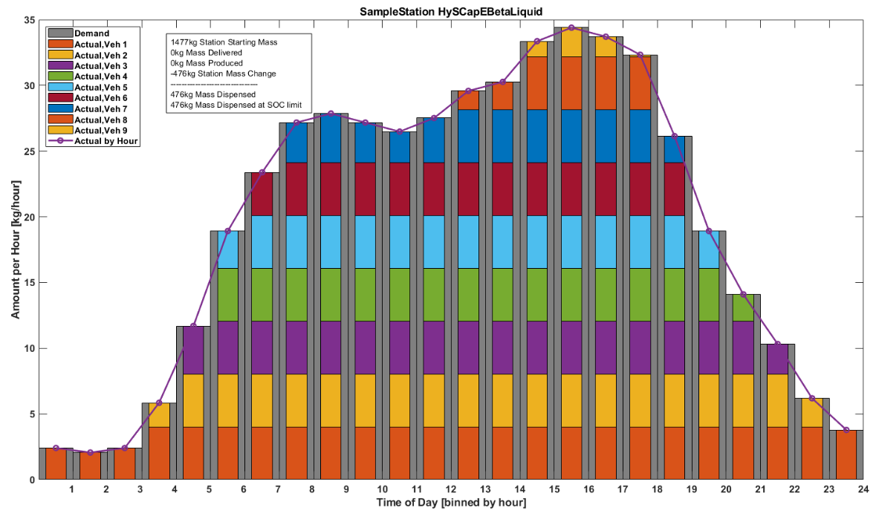

Figure 22. Liquid delivered, ~1,500 kg storage

* 1. Sample Station – Production

This sample station assumes a production rate of 8 kg/hr, with LP, MP, and HP storage. See Figure 22 for the calculated fill data, with the predetermined fueling demand.

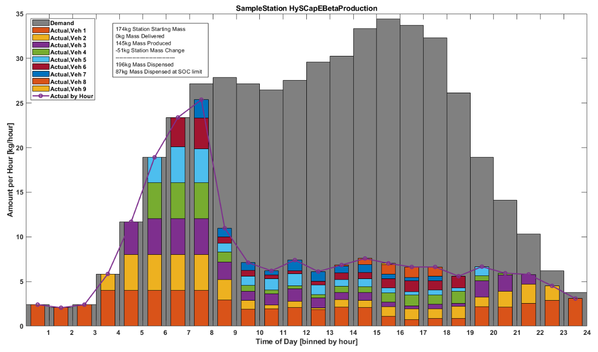

Figure 23. Production, ~200 kg storage

1. Conclusions

The HySCapE model is a consistent and transparent model to calculate the capacity of a hydrogen fueling station based on user inputs for the station configuration. HySCapE station configurations include delivered (gas or liquid) and on-site production (electrolyzer, reformer, and pipeline). HySCapE will have a publicly available online user interface developed later before the end of 2018. The first version of HySCapE is not predictive of actual fueling performance, representative of all possible station configurations, or a design tool for station build or operation.

References

[1] CSA Group, “Hydrogen Fueling Stations CSA HGV 4.9:2016.” CSA Group, Apr-2016.

[2] T.-P. Chen, “Hydrogen Delivery Infrastructure Options Analysis,” DOE Report, Mar. 2014.

1. <https://www.nrel.gov/hydrogen/hitrf-animation.html>